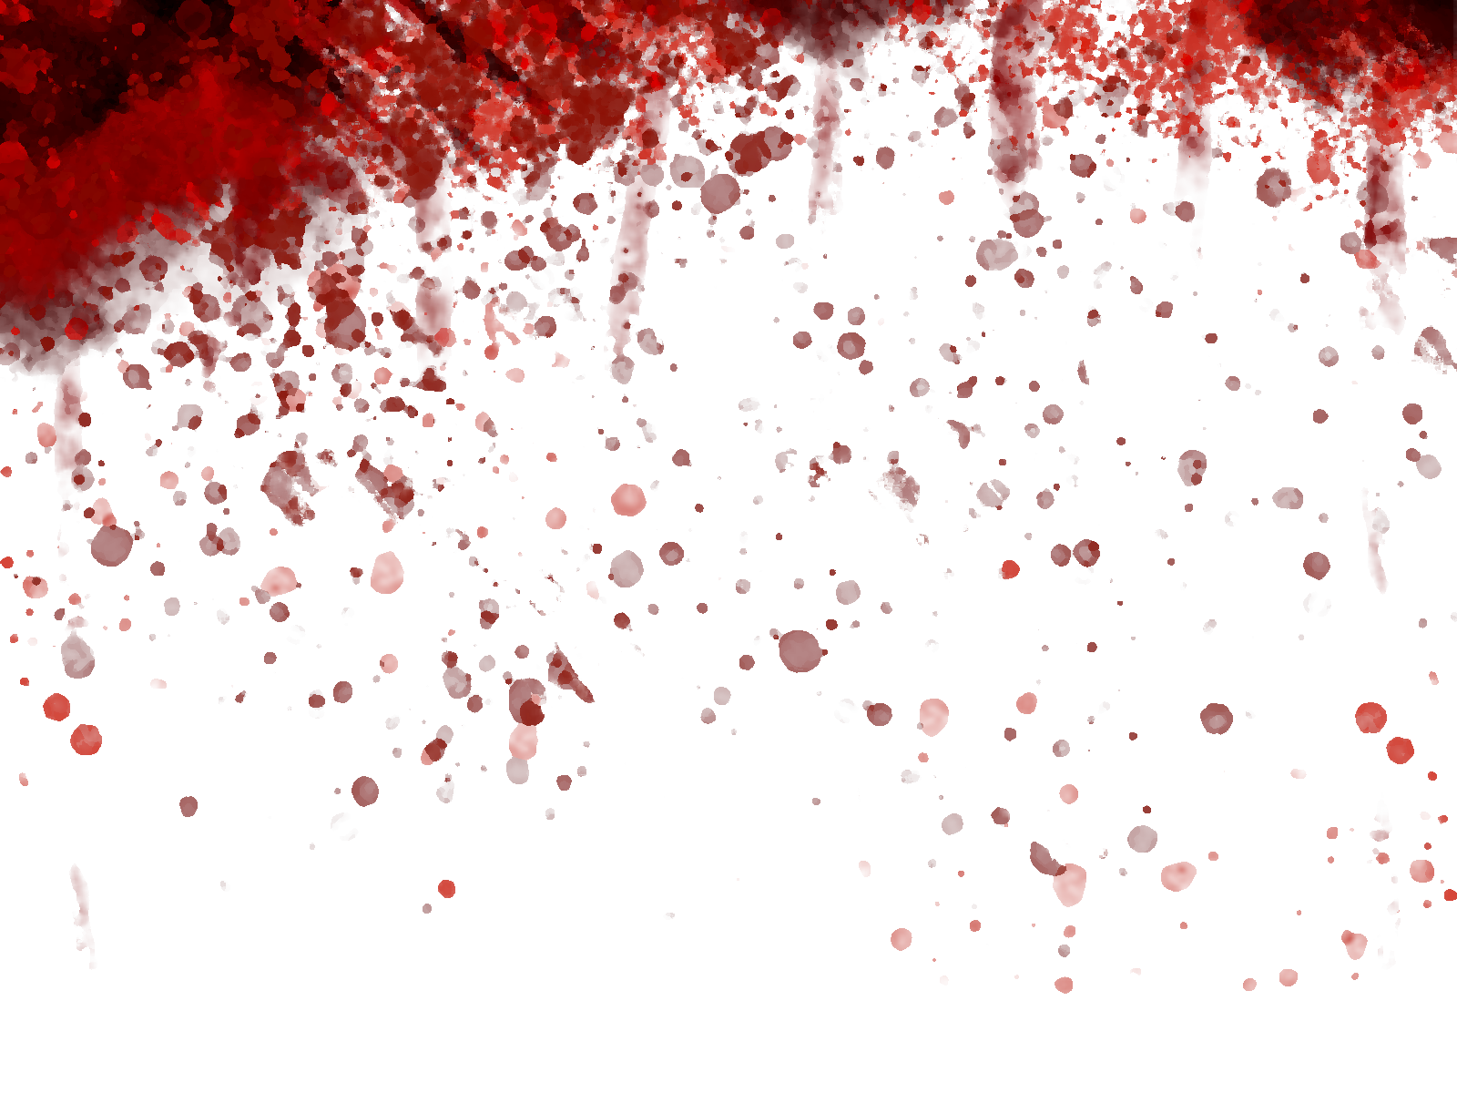
Asorath
Wrath Post Death
A Dark Fantasy Tabletop Roleplaying Game
By Roxxanne Ward.
Table of Contents
GOD IS DEAD. WE KILLED HIM. 3
The Era of the Mages 3
Arcane Intracranial Hematoma 3
THE MODERN DAY 4

GOD IS DEAD. WE KILLED HIM.

The Era of the Mages
During the era of the Mages, Earth (as humans call it) was allegedly ruled by the deity Heieris.
For a reason that has been lost to Cosmic Obscurance, the Nine Mages of the Three Races decided that Heieris may no longer be allowed to inhabit this world or any other, and drove an obsidian spear into his chest.
Heireris, maddened, attempted omnicide and killed 90% of his creations inequally, nearly wiping out all Humans in the process and plunging the world into a dark age.
Soon after Heieris’s attempted Omnicide, a pantheon of gods who had empowered themselves via Toric magic sometime during the rein of Heieris, the Kaleidic Gods, removed Heieris’s skull and mind and imprisoned it in infinite chains.

Arcane Intracranial Hematoma
From the eyes of Heieris’s skull came blood, and following came the shattering of his mind into the Spirits of Blood being Entropy, Malevolence and Rot, and more importantly the Demiurge. What remained was Arcane, the dictator of all nonnatural magic.
The Demiurge was the part of Heieris’s mind which made all of Creation, ambivalent to it. It made good and evil, every shade of gray and every blade of grass, with no regard what terror they bring upon eachother.
The Spirits of Blood
- Entropy, Demonic spirit of Chaos, who paramaterially alters the minds of Their victims in order to drive warmages and kings mad so that the Peoples of Earth may follow a god-emperor controlled by Them.
- Malevolence, Demonic spirit of Violence, who periodically leads necronic armies against the Peoples of Earth in order to dominate them physically and enslave them to lead a great war against the Kaleidic Gods.
- Rot, Demonic spirit of Decay, who wishes to empower the entirety of the Peoples of Earth with Necronic and Zoenic magic so that they may become godlike and revolt against the Kaleidic Gods.

THE MODERN DAY
wip

Basic Mechanics
ASOYU is a very varying game by its own nature of being largely story & player driven, but most campaigns follow a basic gameplay loop:

- The Dungeon Master describes the environment in detail.
A chest on the far wall, a door with a keyhole on the nearest, perhaps a goblin guarding the aforementioned chest and maybe even esoteric symbols covering the walls. Maybe you’re in a bustling city, maybe you’re in a small town well past its golden age. Maybe you’re in a bog or a dense forest. Whatever it is, there’s always something to do!
The DM will in some cases provide a map of the location, but otherwise will describe how many doors lead out of a room or who is in that room, giving the players an ample amount of detail so that they may figure out what they want to do.
- The players then describe what they would like to do.
See a goblin? Lets fight it!
Maybe a stealth-oriented character who has invested into their lockpicking skill will see a particularly interesting-looking locked door and the DM will tell them to skill-roll lockpicking, they end up succeeding the roll with a nat 20, and unfortunately there were not many riches behind the door, but in fact a hooded creature with no face, Uttril the Voracious, an evil spirit given necronic form.
- The DM then describes the results of the players’ actions.
The players successfully fend off the evil soul and banish it to Voulvundan. As a result, several members of the party gain XP, and they find gold on the torn cloth the apparition had donned, only taking minor injuries which will heal passively. Overall, a victory!
Remember that this is a ROLEPLAYING game, where’s the fun in just saying “I attack the Golem with Swing”? Describe what you do in detail, say how you swing at the golem, from what angle, etc, you have all played DND before.
Additionally, don’t be a dick about rules, nobody likes a rules lawyer who thinks every rule is written in stone and must be followed letter-by-letter. Vibes are fun too.

Character Creation
All campaigns start with the creation of the party’s characters. Here, you will select a people, class and backstory, in addition to selecting your starting stats.

People and Races.
Asorath is a very diverse world, and as such, there are many Peoples, traditionally called Races, to pick from. While no people is inherently better than another in this World after Death, some were favored by Heieris in their creation or are materially shaped by the Kaleidic gods.

Elves
The first creation of Heieris, according to Elven myth. They call themselves Eladorin and primarily speak Elvish, with lowermen often speaking Trade and uppermen often speaking Noble. All party characters speak Common, the diplomatic language based on Wessuric Elvish.
Stride | Size |  |  | Languages
12 | Medium |  |  | Teidaric Elvish or Wessuric Elvish depending on Culture | Trade if following a Lower Class backstory or Noble Elvish if following an Upper Class backstory.

Teidar Elves
The primary culture of Elves north of The Middle, typically bearing all-white hair and green-on-white eyes. Teidar Elve cities are rich but often encircled by a large ring of slums, inhabited primarily by the lower class, immigrants and non-elves.

Wessuric Elves

